**Name : Nayan Mandliya**

**Roll No. : 1911027**

**Batch : MERN 1**

**Experiment No. : 2**

**Title:** Implementation of Express. js

**Problem statement:** Consider the basic concepts of Express.js, which are useful in the creation of an application. Considering the following points, demonstrate the functionality of each with a simple script.

**1) Scaffolding:** 1. Demonstrate express scaffolding to fulfill the following requirements. Example: Consider Grocery Delivery Application and demonstrate the Scaffolding. Scaffold the application to create different routes such as. Sign up Page: (Root/ Homepage)

**Code:**

**Folder Structure:**

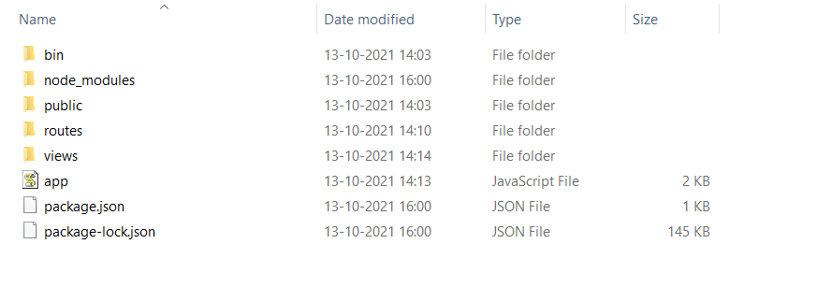

**App.js:**

var createError = require('http-errors');

var express = require('express');

var path = require('path');

var cookieParser = require('cookie-parser');

var logger = require('morgan');

var indexRouter = require('./routes/index');

var signupRouter=require('./routes/signup');

var signinRouter=require('./routes/signin');

var showgroceriesRouter=require('./routes/showgroceries');

var app = express();

// view engine setup

app.set('views', path.join(__dirname, 'views'));

app.set('view engine', 'jade');

app.use(logger('dev'));

app.use(express.json());

app.use(express.urlencoded({ extended: false }));

app.use(cookieParser());

app.use(express.static(path.join(__dirname, 'public')));

app.use('/', indexRouter);

app.use('/signup', signupRouter);

app.use('/signin', signinRouter);

app.use('/showgroceries', showgroceriesRouter);

// catch 404 and forward to error handler

app.use(function(req, res, next) {

  next(createError(404));

});

// error handler

app.use(function(err, req, res, next) {

  // set locals, only providing error in development

  res.locals.message = err.message;

  res.locals.error = req.app.get('env') === 'development' ? err : {};

  // render the error page

  res.status(err.status || 500);

  res.render('error');

});

module.exports = app;

**Index.js:**

var express = require('express');

var router = express.Router();

var MClient=require('mongodb').MongoClient;

var url="mongodb://localhost:27017/"

var results=[]

/* GET home page. */

router.get('/', function(req, res, next) {

  MClient.connect(url,(err,db)=>{

    if(err)

    {

        throw err;

    }

    else

    {

        var dbase=db.db('EXP2');

        dbase.collection('Users').find({}).toArray((err,result)=>{

            if(err)

            {

                throw err;

            }

            else

            {

                results.push(result);

                res.render('index', { title: 'Express', "results": results });

                db.close();

            }

        })

    }

})

});

module.exports = router;

**Index.jade:**

extends layout

block content

  h1.header Online Grocery Delivery System

  div.con

    a.temp(href='http://localhost:3000/signin') Sign in

    a.temp(href='http://localhost:3000/signup') Sign up

**Showgroceries.js:**

var express = require('express');

var router = express.Router();

router.get('/',function(req,res,next){

    res.render('showgroceries');

})

module.exports = router;

**Showgroceries.jade:**

extends layout

block script

  script(language='javascript').

    var i=0;

    window.onload = function(e){

      i=0;

      document.getElementById('counter').innerHTML=i;

    }

    function addition(){

      i=i+1;

      document.getElementById('counter').innerHTML=i;

      console.log(i);

    }

block content

  p.header3 Groceries

  p.show Items added :

  span#counter

  button.w3-btn(onclick="document.getElementById('id01').style.display='block'") Deliver

  div#id01.w3-modal

    div.w3-modal-content

      div.w3-container

        span.w3-closebtn(onclick="document.getElementById('id01').style.display='none'") ×

        p.temppar All items will be delivered thank you for using our services!!

  br

  br

  br

  br

  br

  div.card

    img(src='/images/sauce.jpg' alt='Avatar' style='width:30%; margin-left: 150px; height: 150px')

    div.containern

      h4

        b Sauce

      p.first Price: &#8377; 100

      button(onclick='addition()').button.button1 &#43; Add

  div.card

    img(src='/images/sprite.jpg' alt='Avatar' style='width:30%; margin-left: 150px; height: 150px')

    div.containern

      h4

        b Sprite

      p.first Price: &#8377; 70

      button(onclick='addition()').button.button1 &#43; Add

  div.card

    img(src='/images/wafers.jpg' alt='Avatar' style='width:30%; margin-left: 150px; height: 150px')

    div.containern

      h4

        b Wafers

      p.first Price: &#8377; 10

      button(onclick='addition()').button.button1 &#43; Add

  div.card

    img(src='/images/icecream.jpg' alt='Avatar' style='width:30%; margin-left: 150px; height: 150px')

    div.containern

      h4

        b Icecream

      p.first Price: &#8377; 135

      button(onclick='addition()').button.button1 &#43; Add

  div.card

    img(src='/images/naturals.jpg' alt='Avatar' style='width:30%; margin-left: 150px; height: 150px')

    div.containern

      h4

        b Naturals

      p.first Price: &#8377; 70

      button(onclick='addition()').button.button1 &#43; Add

  div.card

    img(src='/images/little.jpg' alt='Avatar' style='width:30%; margin-left: 150px; height: 150px')

    div.containern

      h4

        b.temper Little Hearts

      p.first Price: &#8377; 10

      button(onclick='addition()').button.button1 &#43; Add

  br

  br

  br

  br

  a(href='http://localhost:3000/' style='color: rgb(22.4%, 100%, 7.8%); font-size: 30px').guider &#8592; Back to home page

**Signin.js:**

var express = require('express');

var router = express.Router();

var Mclient=require('mongodb').MongoClient;

var url='mongodb://localhost:27017/';

router.get('/',function(req,res,next){

    res.render('signin');

})

router.post('/', function (req, res) {

    Mclient.connect(url,(err,db)=>{

        if(err)

        {

            throw err;

        }

        else

        {

            console.log("Connection Established!!");

            var dbase=db.db('EXP2');

            dbase.collection('users').find({}).toArray((err,result)=>{

                if(err)

                {

                    throw err;

                }

                else

                {

                    var i=0;

                    var flag=0;

                    for(i=0;i<result.length;i++)

                    {

                        if(result[i].username==req.body.username)

                        {

                            flag=1;

                            if(result[i].password==req.body.password)

                            {

                                res.render('showgroceries');

                            }

                        }

                    }

                    if(flag==0)

                    {

                        res.render('signin');

                    }

                    db.close();

                }

            })

        }

    })

})

module.exports = router;

**Signin.jade:**

extends layout

block content

  div.container

    p.header1 Sign In

    br

    br

    br

    form(name="add-estimation", method="post")

          div.input

              span.label1 Username:

              input(type="text", name="username")

          br

          br

          br

          div.input

              span.label2 Password:

              input(type="text", name="password")

          br

          br

          br

          div.actions

            input.buttoner(type="submit", value="Sign In")

**Signup.js:**

var express = require('express');

var router = express.Router();

var Mclient=require('mongodb').MongoClient;

var url='mongodb://localhost:27017/';

router.get('/',function(req,res,next){

    res.render('signup');

})

router.post('/', function (req, res) {

    Mclient.connect(url,(err,db)=>{

        if(err)

        {

            console.log(err);

            throw err;

        }

        else

        {

            console.log("Connection Established!!")

            var obj=[{username: req.body.username, password: req.body.password}];

            var dbase=db.db('EXP2');

            dbase.collection('users').insert(obj,(err,res)=>{

                if(err)

                {

                    console.log(err);

                }

                else

                {

                    console.log("Collection inserted using insert!!!");

                    db.close();

                }

            })

        }

    })

    res.render('signin');

});

module.exports = router;

**Signup.jade:**

extends layout

block content

  div.container

    p.header1 Sign Up

    br

    br

    br

    form(name="add-estimation", method="post")

          div.input

              span.label1 Username:

              input(type="text", name="username")

          br

          br

          br

          div.input

              span.label2 Password:

              input(type="text", name="password")

          br

          br

          br

          div.actions

            input.buttoner(type="submit", value="Sign Up")

**Error.jade:**

extends layout

block content

  p.showcontent ERROR PAGE

**Layout.jade:**

doctype html

html

  head

    title= title

    link(rel='stylesheet', href='/stylesheets/style.css')

    block script

  body

    block content

**Output:**

**Home page:**

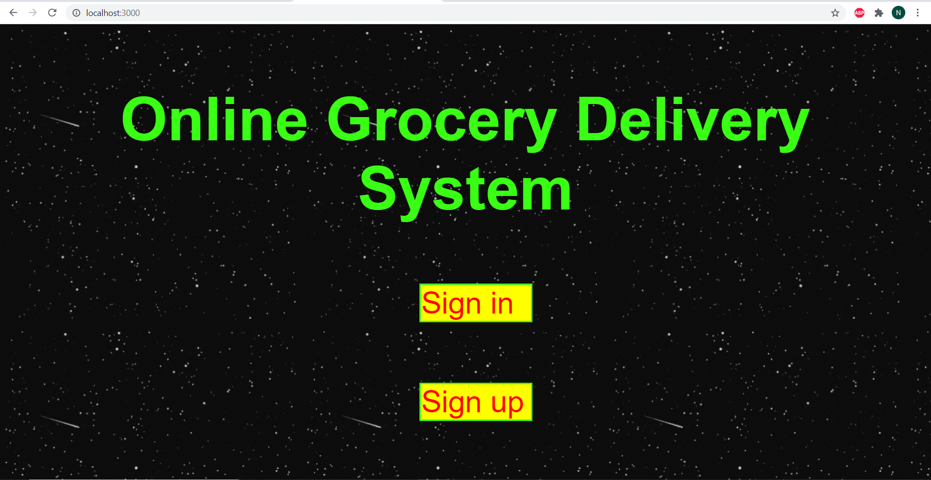

**Signup page:**

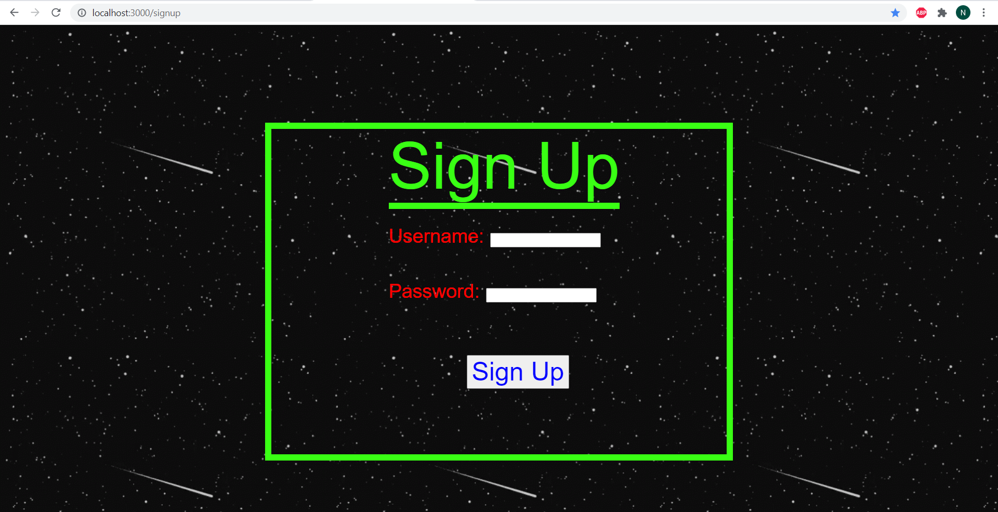

**Signin page:**

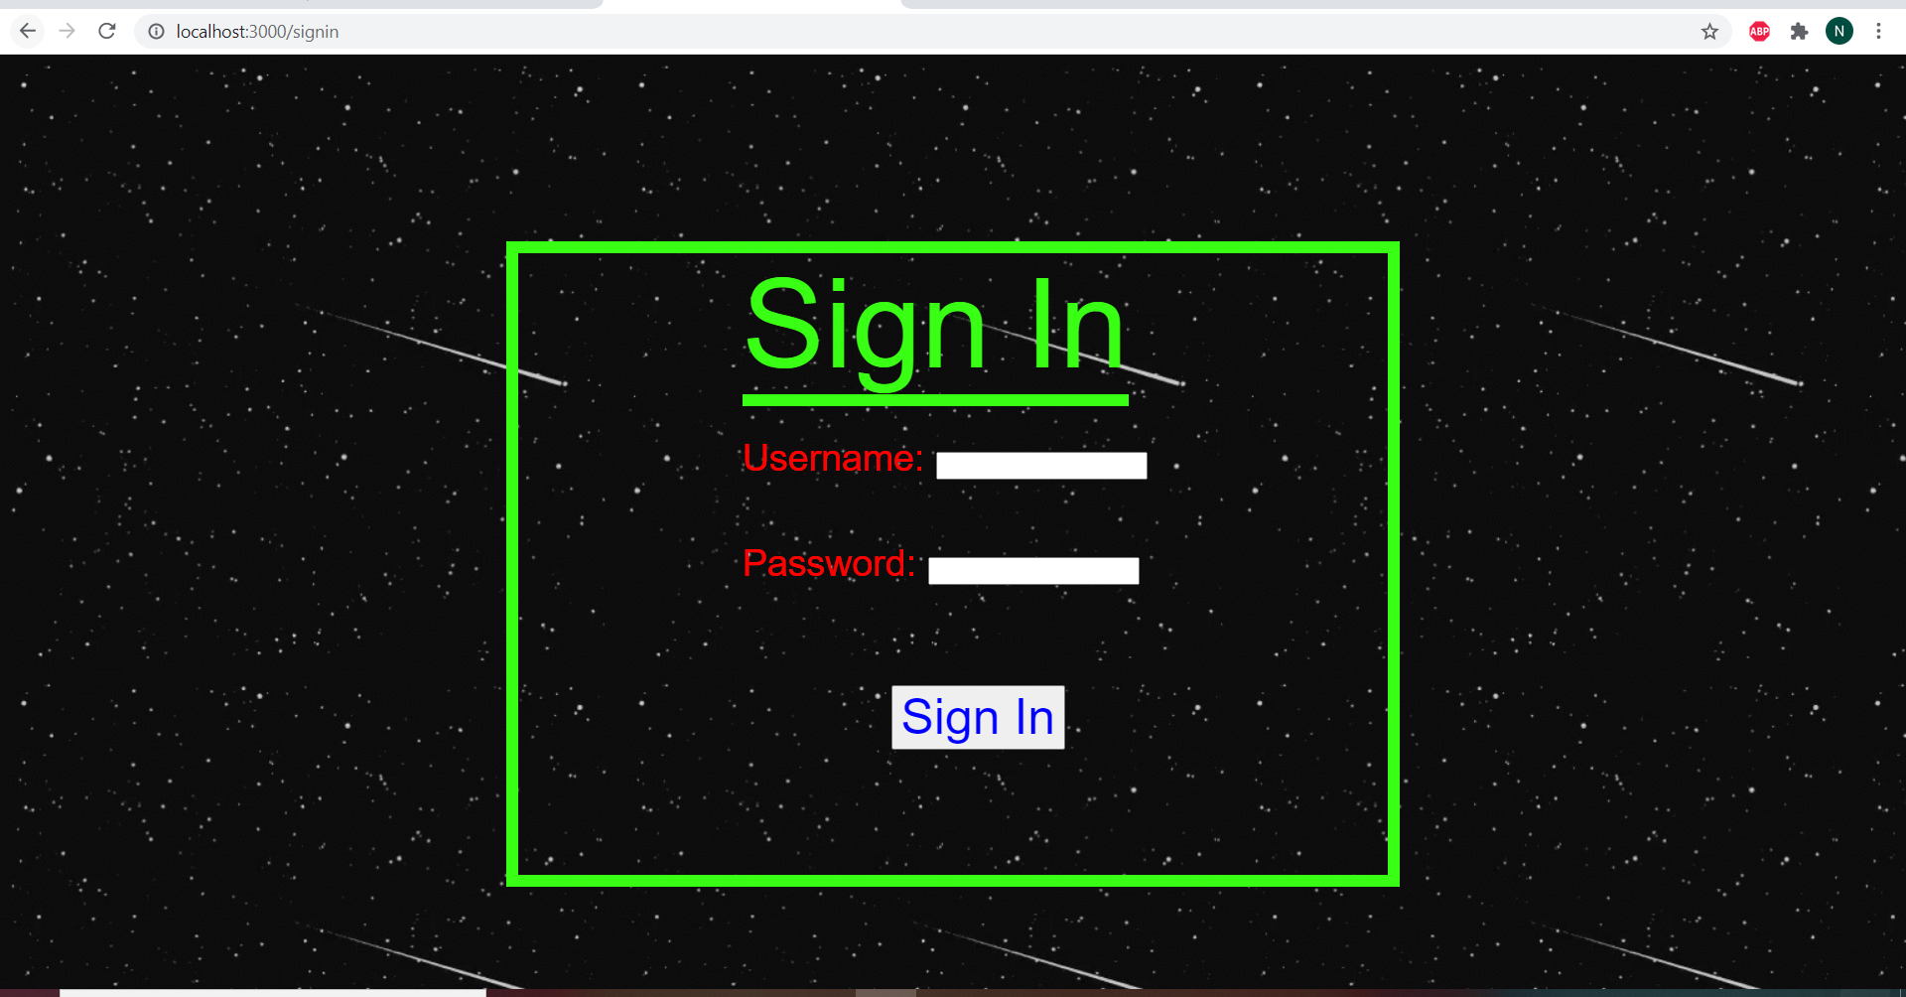

**Mongodb database:**

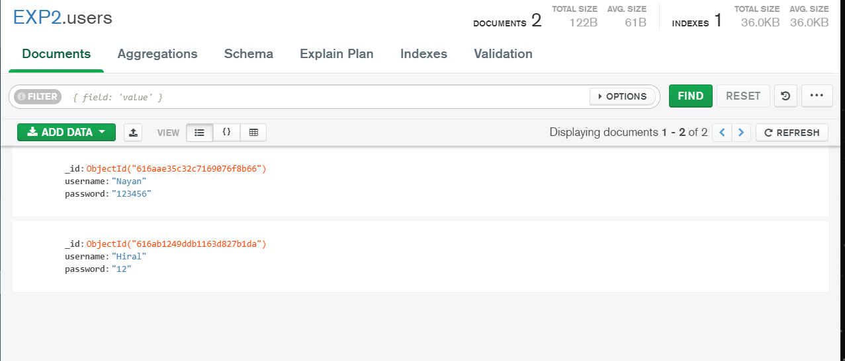

**Showgroceries page (if correct credentials are entered):**

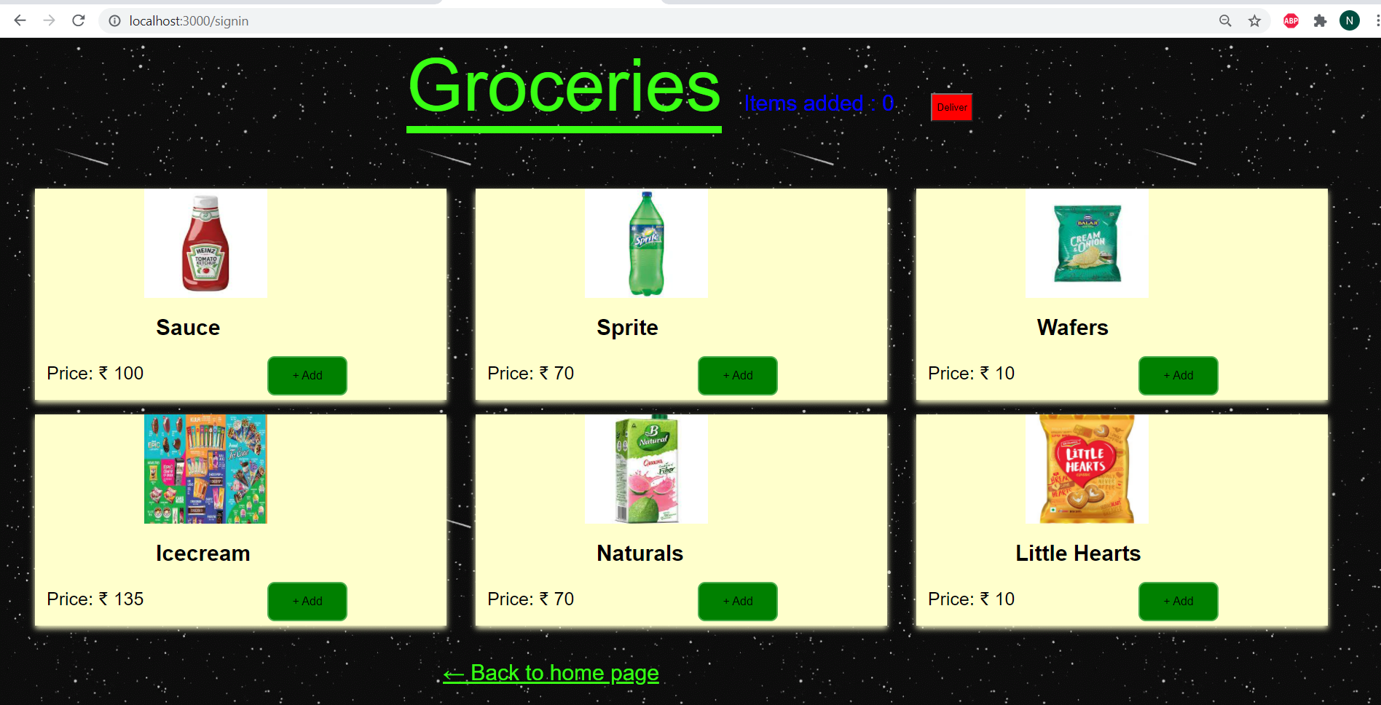

**If deliver button is clicked:**

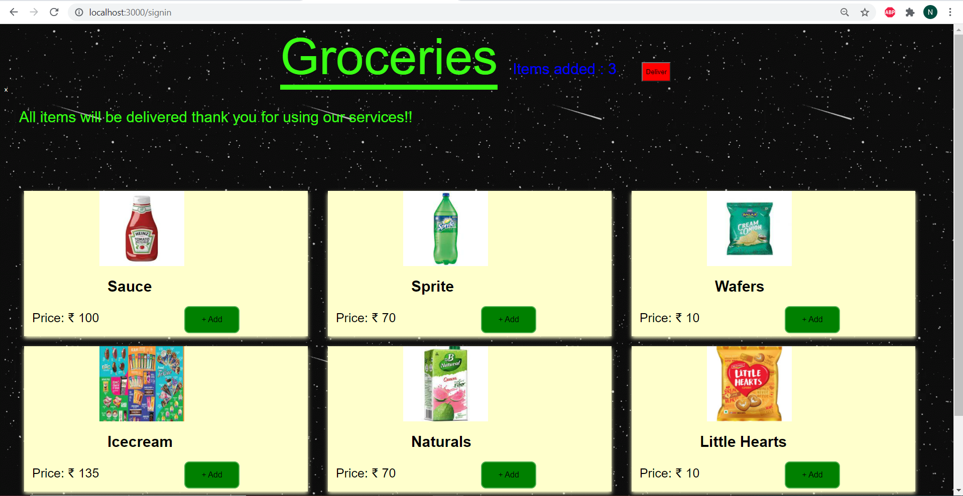

**Error page:**

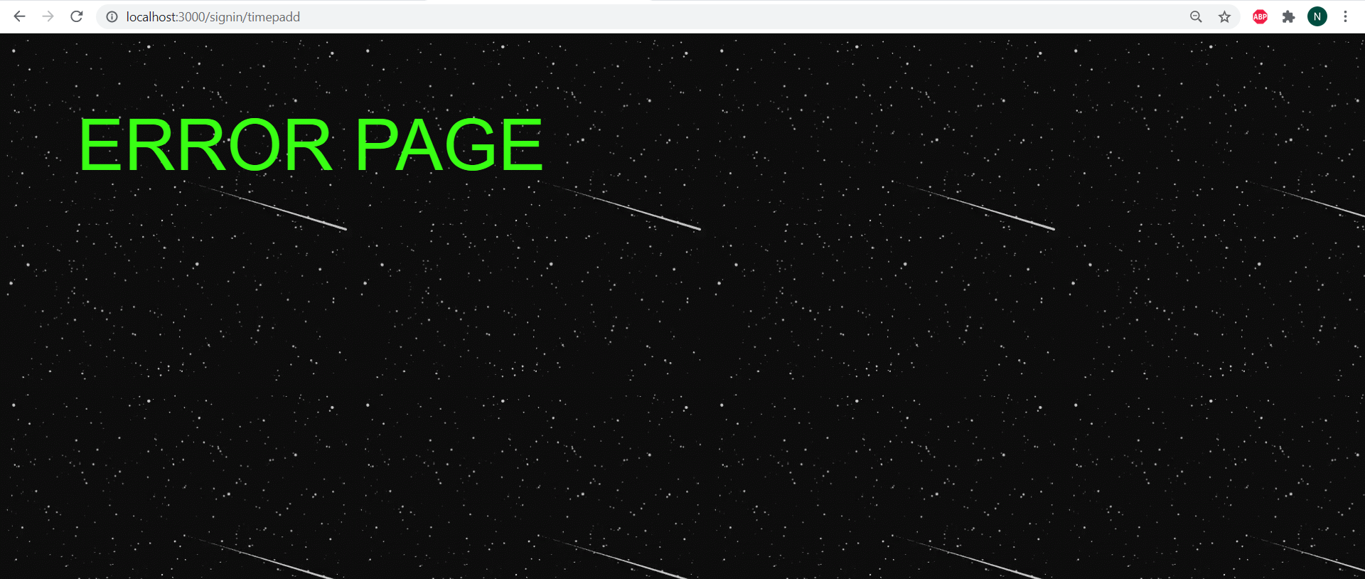

**2) Types of Middleware: Authentication.** Example: Demonstrate the use of Express middleware with different types of middleware.

**1. Application-level middleware:**

**Example1:**

**Code:**

**Index.js:**

// Application level middleware

const express=require('express');

const app=express();

const path=require('path');

const publicpath=path.join(__dirname,"./public");

app.use(express.static(publicpath));

app.get("/",(req,res,next)=>{

    res.sendFile(path.join(__dirname, './public/index.html'));

    next();

})

app.get("/",(req,res,next)=>{

    console.log("Next middleware called successfully!!!");

})

app.post("/",(req,res,next)=>{

    console.log("Data stored in the database successfully!!!!");

})

app.listen(5000,(req,res)=>{

    console.log("Server listening on port 5000!!!");

})

**Index.html:**

<!DOCTYPE html>

<html lang="en">

<head>

    <meta charset="UTF-8">

    <meta http-equiv="X-UA-Compatible" content="IE=edge">

    <meta name="viewport" content="width=device-width, initial-scale=1.0">

    <title>Document</title>

    <link rel="stylesheet" href="css/main.css" />

</head>

<body>

    <h1>Application Level Middleware</h1>

    <p>This page is created for application level middleware use!!!!!</p>

    <form method="POST">

        <input type="submit" value="Post">

    </form>

</body>

</html>

**Main.css:**

body{

    background-color: black;

    color: blue;

}

**Output:**

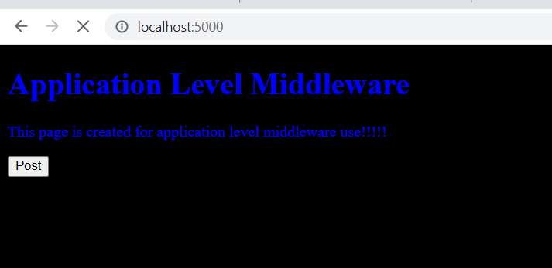

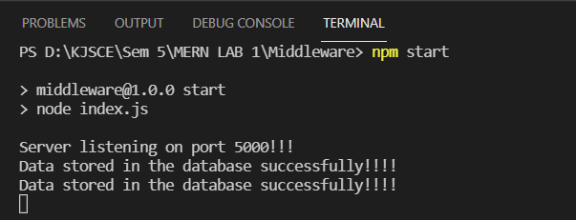

**Example2:**

**Code:**

const express = require('express')

const app = express()

//  req => middleware => res

const path=require('path');

const publicpath=path.join(__dirname,"./public");

const logger=(req,res,next)=>{

  console.log("Method: ",req.method,"  URL: ",req.url,"  Year: ",new Date().getFullYear())

  next()

}

app.get('/', logger,(req, res) => {

    res.sendFile(path.join(__dirname, './public/index.html'));

})

app.post('/',logger,(req,res)=>{

    console.log("Data stored in the database successfully!!!");

})

app.listen(5000,()=>{

  console.log('Server is listening on port 5000!!!!');

})

**Output:**

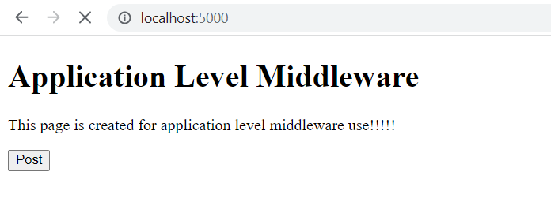

**When post button is clicked than app.post will be called and output will be displayed:**

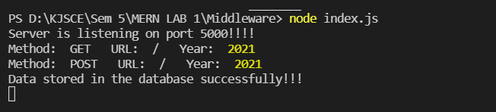

**2. Router-level middleware:**

**Code:**

**Routerlevel.js:**

const express=require('express');

const app=express();

const router=express.Router();

const path=require('path');

router.get('/',(req,res,next)=>{

    res.sendFile(path.join(__dirname, './public/index2.html'));

})

router.post('/',(req,res,next)=>{

    console.log("Data stored on the database successfully!!!!");

    res.send("Done");

    next();

})

app.use('/', router)

app.listen(5000,()=>{

    console.log("Server listening on port 5000!!!!");

});

**Index2.html:**

<!DOCTYPE html>

<html lang="en">

<head>

    <meta charset="UTF-8">

    <meta http-equiv="X-UA-Compatible" content="IE=edge">

    <meta name="viewport" content="width=device-width, initial-scale=1.0">

    <title>Document</title>

</head>

<body>

    <h1>Router Level Middleware</h1>

    <p>This page is created for router level middleware use!!!!!</p>

    <form method="POST">

        <input type="submit" value="Post">

    </form>

</body>

</html>

**Output:**

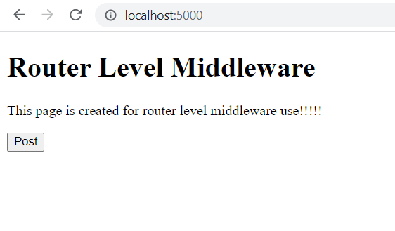



**After post button is clicked:**

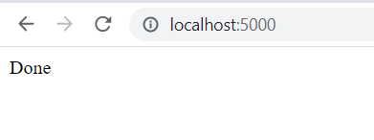

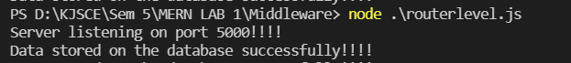

**3. Error-handling middleware: like 404 or page not found error handler:**

**Code:**

**Errorhandling.js:**

const express=require('express');

const app=express()

const path=require('path');

app.get('/',(req,res,next)=>{

    res.sendFile(path.join(__dirname, './public/index3.html'));

})

app.post('/',(req,res,next)=>{

    next(new Error("You have posted something that is errorneous!!!"));

})

app.use((err,req,res,next)=>{

    res.status(404).send(err.message);

})

app.listen(5000,()=>{

    console.log("Server listening on port 5000!!!");

})

**Index3.html:**

<!DOCTYPE html>

<html lang="en">

<head>

    <meta charset="UTF-8">

    <meta http-equiv="X-UA-Compatible" content="IE=edge">

    <meta name="viewport" content="width=device-width, initial-scale=1.0">

    <title>Document</title>

    <link rel="stylesheet" href="css/main.css" />

</head>

<body>

    <h1>Error Handling Middleware</h1>

    <p>This page is created for error handling middleware use!!!!!</p>

    <form method="POST">

        <input type="submit" value="Post">

    </form>

</body>

</html>

**Output:**

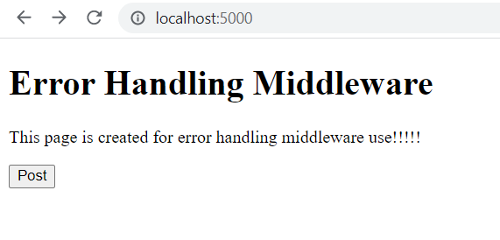

**After post button is clicked:**

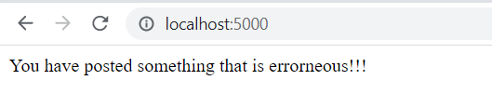

**4. Built-in middleware: express.static, express.json and express.urlencoded:**

**1) express.static:**

**Code:**

const express=require('express');

const app=express();

const path=require('path');

app.use(express.static(path.join(__dirname,'public2')))

app.get('/', function (req, res, next) {

    res.render('index.html');

})

app.listen(5000,()=>{

    console.log("Server listening on port 5000!!!!");

});

**HTML file:**

<!DOCTYPE html>

<html lang="en">

<head>

    <meta charset="UTF-8">

    <meta http-equiv="X-UA-Compatible" content="IE=edge">

    <meta name="viewport" content="width=device-width, initial-scale=1.0">

    <title>Document</title>

    <link rel="stylesheet" href="css/main.css" />

</head>

<body>

    <h1>Builtin Middleware</h1>

    <p>This page is created for builtin middleware use!!!!!</p>

</body>

</html>

**Output:**

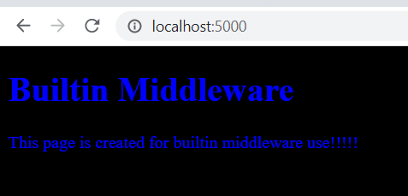

**2) express.json:**

**Code:**

**With express.json:**

const express=require('express');

const app=express();

app.use(express.json());

app.post('/post',(req,res)=>{

    res.send("Hiii "+req.body.name+" You are currently in "+req.body.year+" year");

    res.end();

})

app.listen(5000,()=>{

    console.log("Server listening on port 5000!!!!");

})

**Without express.json:**

const express=require('express');

const app=express();

// app.use(express.json());

app.post('/post',(req,res)=>{

    res.send("Hiii "+req.body.name+" You are currently in "+req.body.year+" year");

    res.end();

})

app.listen(5000,()=>{

    console.log("Server listening on port 5000!!!!");

})

**Output:**

**With express.json:**

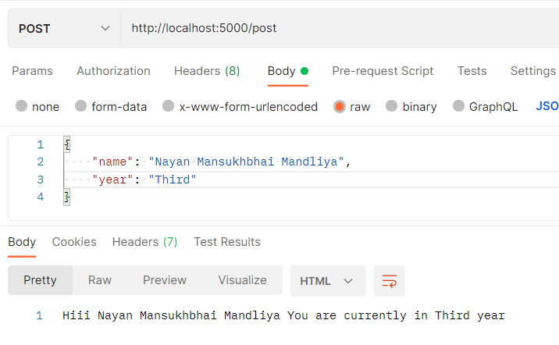

**Without express.json:**

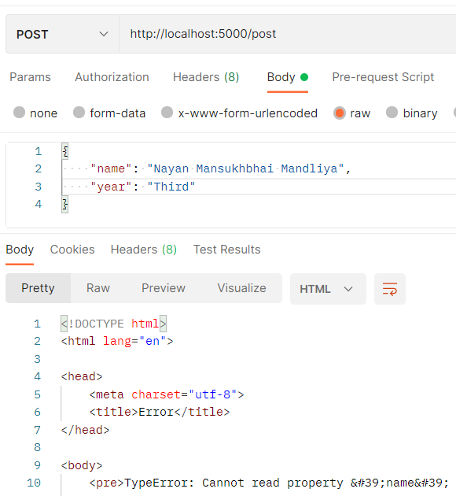

**3) express.urlencoded:**

**Code:**

**HTML file:**

<!DOCTYPE html>

<html lang="en">

<head>

    <meta charset="UTF-8">

    <meta http-equiv="X-UA-Compatible" content="IE=edge">

    <meta name="viewport" content="width=device-width, initial-scale=1.0">

    <title>Document</title>

    <link rel="stylesheet" href="css/main.css" />

</head>

<body>

    <h1>Builtin Middleware</h1>

    <p>This page is created for builtin middleware use!!!!!</p>

    <form action="/" method="POST">

        Username : <input type="text" name="username">

        <br>

        Password : <input type="text" name="password">

        <br>

        <button>Submit</button>

    </form>

</body>

</html>

**With urlencoded:**

const express=require('express');

const app=express();

app.use(express.urlencoded({extended:false}));

const path=require('path');

app.get('/',(req,res,next)=>{

    res.sendFile(path.join(__dirname, './public3/temp.html'));

})

app.post("/", (req, res) => {

    res.send(req.body)

})

app.listen(5000,()=>{

    console.log("Server listening on port 5000!!!!");

});

**Without urlencoded:**

const express=require('express');

const app=express();

// app.use(express.urlencoded({extended:false}));

const path=require('path');

app.get('/',(req,res,next)=>{

    res.sendFile(path.join(__dirname, './public3/temp.html'));

})

app.post("/", (req, res) => {

    res.send(req.body)

})

app.listen(5000,()=>{

    console.log("Server listening on port 5000!!!!");

});

**Output:**

**With urlencoded:**

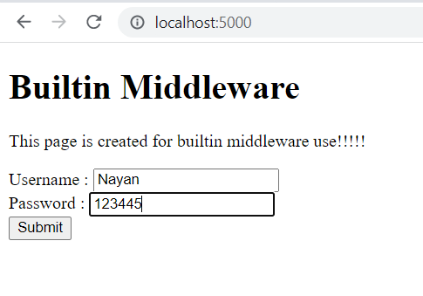

**After clicking submit button:**

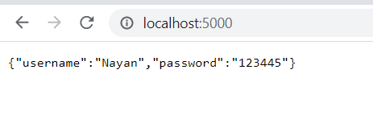

**Without urlencoded:**

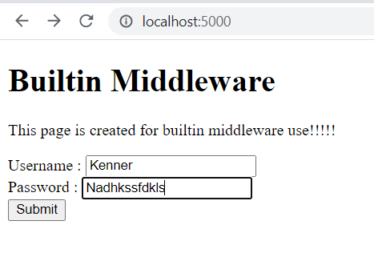

**After clicking submit button: Nothing will be shown.**

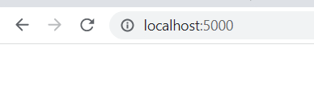

**5. Third-party middleware: morgan(): This middlewear will give log of all the requests. If tiny is passed in the morgan than it will give logs in shorter format as shown in the example below.**

**Code:**

const express=require('express');

const morgan=require('morgan');

const app=express();

app.use(morgan('tiny'));

app.get('/',(req,res)=>{

    res.send('GET request!!!');

})

app.post('/',(req,res)=>{

    res.send('POST request!!!');

})

app.delete('/',(req,res)=>{

    res.send('DELETE request!!!');

})

app.listen(5000,()=>{

    console.log("Server listening on port 5000!!!!");

})

**Output:**

**All requests made:**

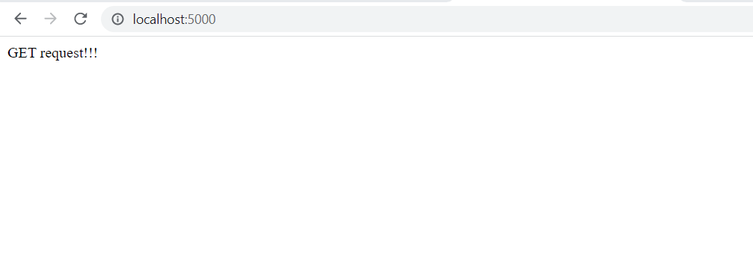

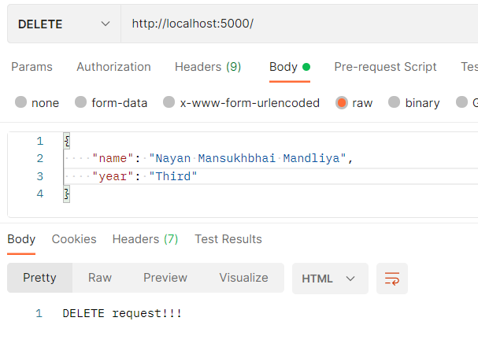

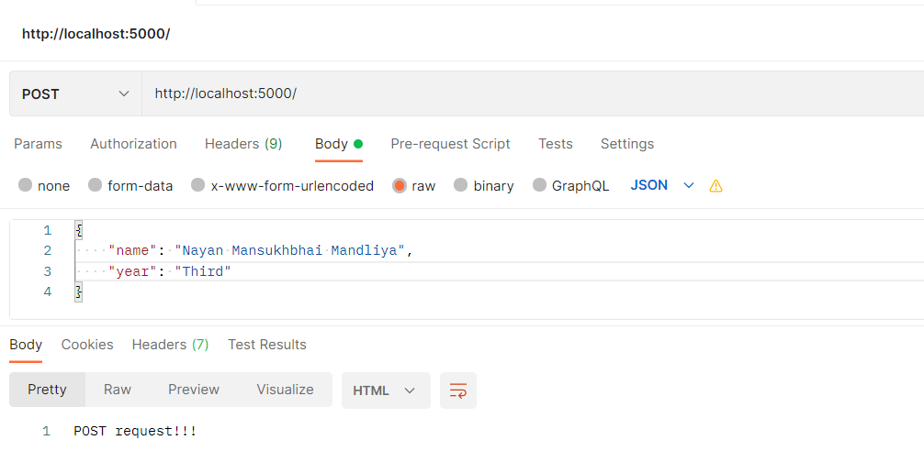

**Logs:**

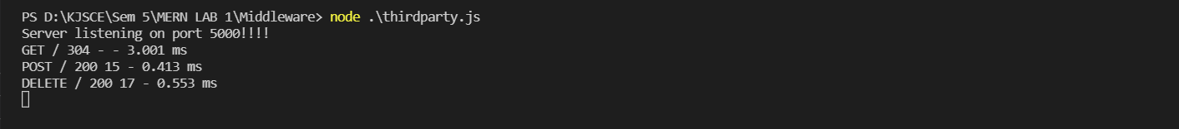

**3) Serving static files using Express.js: With the help of Built in middleware, express.Static () to demonstrate the usage of serving static files in express.** **To demonstrate the above make a use of Use of images where it should accept any type of image, Use of CSS and HTML files and Make a Use json file of employee information, add file to the static folder, and show the response on the browser.**

**Folder structure:**

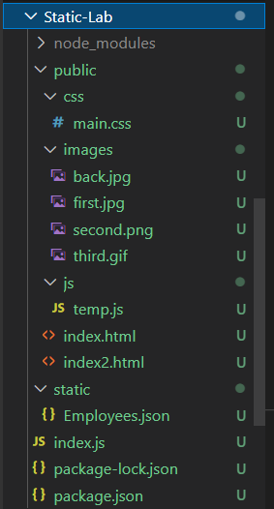

**Code:**

**index.js:**

const express=require('express');

const app=express();

app.use(express.static('public'));

app.use(express.static('static'));

app.get('/',(req,res)=>{

    res.end("Hello!!");

})

app.get('/stat',(req,res)=>{

    res.sendFile("index2.html", {root: "public"});

})

app.get('/json',(req,res)=>{

    res.sendFile("Employees.json",{root: "static"});

})

app.listen(5000,()=>{

    console.log("Server listening on port 5000!!!!");

})

**index.html:**

<!DOCTYPE html>

<html lang="en">

<head>

    <meta charset="UTF-8">

    <meta http-equiv="X-UA-Compatible" content="IE=edge">

    <meta name="viewport" content="width=device-width, initial-scale=1.0">

    <title>Document</title>

</head>

<body>

    <h1 class="maker">This is the index page of my website.</h1>

    <h1>JPG Image</h1><img src="images/first.jpg" width="100%" height="600px">

    <h1>PNG Image</h1><img src="images/second.png" width="100%" height="600px">

    <h1>GIF Image</h1><img src="images/third.gif" width="100%" height="600px">

</body>

</html>

**index2.html:**

<!DOCTYPE html>

<html lang="en">

<head>

    <meta charset="UTF-8">

    <meta http-equiv="X-UA-Compatible" content="IE=edge">

    <meta name="viewport" content="width=device-width, initial-scale=1.0">

    <title>Document</title>

    <link rel="stylesheet" href="css/main.css" />

    <script src="js/temp.js"></script>

</head>

<body>

    <div class="images">

        <div class="content">

            This is a static page created for

        </div>

        <div class="content2">

            EXP2

        </div>

        <button class="buttonmaker" onclick='onclicker()' >click</button>

    </div>

</body>

</html>

**main.css:**

.images{

    background-image: url('../images/back.jpg');

    height: 97vh;

}

.content{

    color: #39FF14;

    font-size: 100px;

    margin-left: 150px;

    padding-top: 250px;

}

.content2{

    color: #39FF14;

    font-size: 100px;

    margin-left: 600px;

}

.buttonmaker{

    padding: 20px 20px;

    background-color: bisque;

    margin-left: 680px;

}

**temp.js:**

function onclicker(){

    alert("JS integrated successfully!!!");

}

**Output:**

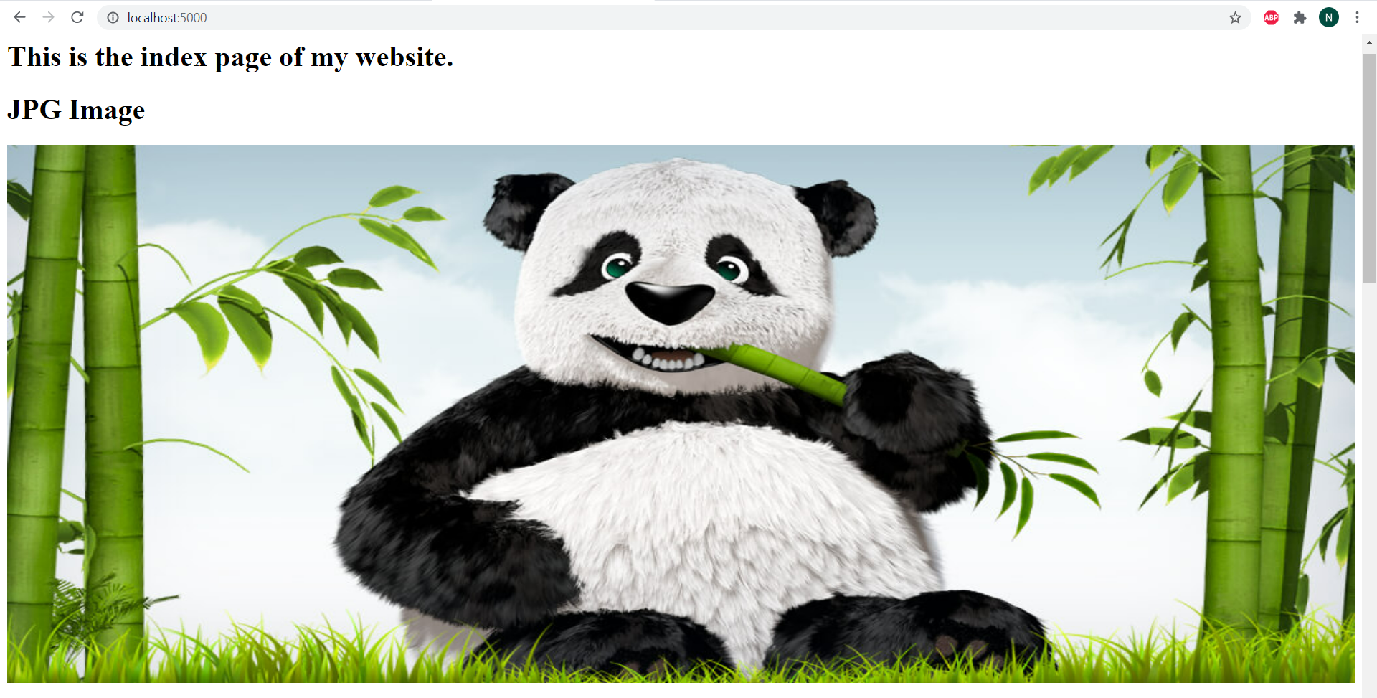

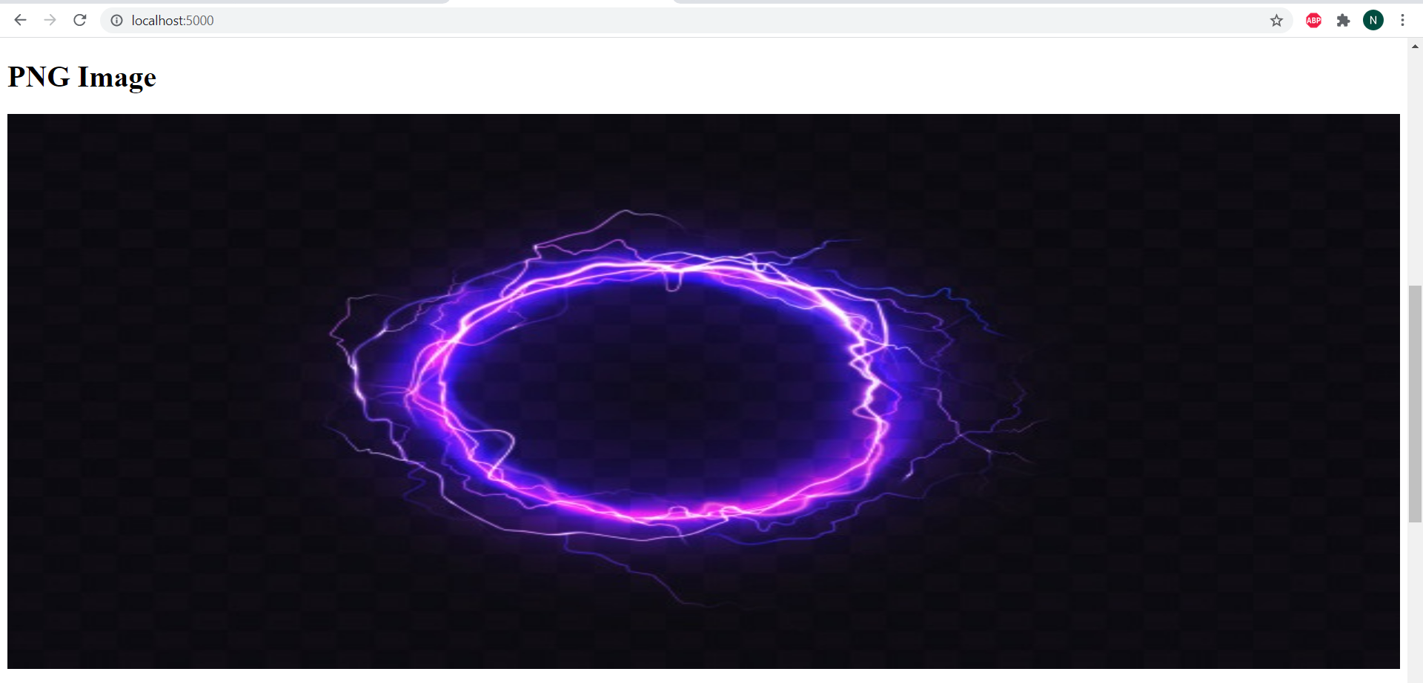

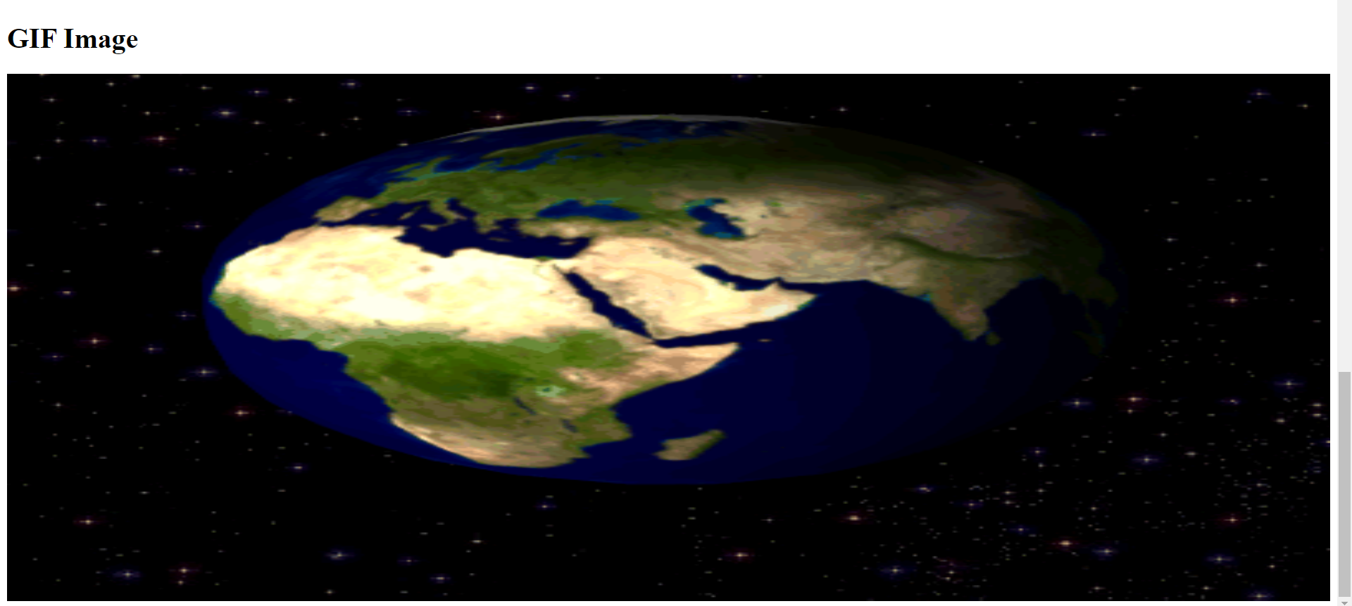

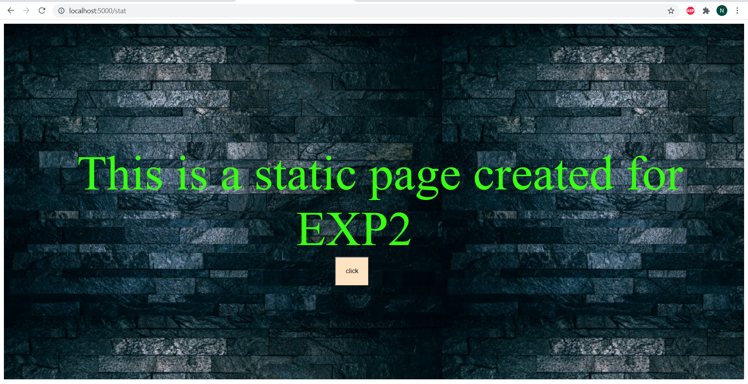

**After clicking button:**

